**HCD Research Toolkit for Clients**

**A set of recommended templates and approaches to strengthen human-centered design (HCD) research**  
February 28, 2023

**Note:** This document is a work in progress and subject to change.

# Table of Contents

**Research Template Use Cases 3**

Planning 3

Recruitment 3

Informed Consent 4

Capturing Insights 4

Follow-Up 4

Reporting 4

**Research Plan Template 5**

Purpose 5

Goals 5

Methods 5

Sampling & recruitment strategy 5

Questions 5

Tools 6

Timeline 6

Task list 6

**Research Brief One-Pager 7**

Purpose of research 7

Research logistics 7

Research goals [optional] 7

Deliverables 7

**Communications Templates 8**

Template for a usability test 9

Template for an interview 10

Template for a follow-up email 11

**Informed Consent Options 12**

Informed consent one-pager 12

Informed consent script 13

# **Research Template Use Cases**

The following use cases offer some example situations you might encounter as a researcher and links to templates that can help.

## Planning

| As a researcher, I’m putting together a research plan for my team to review. |
| --- |

↳ Check out the Research Plan Template

## Recruiting

| As my team is planning research activities, we need a diverse range of participants and an automated process for users to indicate their interest and sign up for studies. |
| --- |

↳ Check out the ServiceNow participant interest form prototype in Figma [work in progress]

↳ Check out the participant screener form in MS Forms [work in progress]

| As my team is reaching out to potential participants, we want to offer a clear idea of what the research is about and what participation would involve. |
| --- |

↳ Check out the Research Brief One-Pager Template

| As someone recruiting for a study, I want standard language to use in recruitment emails. |
| --- |

↳ Check out the Communications Templates

## Informed ConsentAs a researcher who cares about protecting participant privacy, I have two options for providing informed consent to my participants.

↳ This form if I *don’t* have time during the interview

↳ This script if I *do* have time during the interview

## Capturing Insights

| As a designer and frequent observer and note-taker for research activities, I want a standard template for taking the best notes. |
| --- |

↳ Check out these Tips for Note-Taking

↳ Adapt the automated note-taking form and companion database

## Follow-Up

As a researcher, I want to follow up with participants to thank them for their time and share insights and outcomes.

↳ Check out the thank you email template

↳ Check out the post-study follow-up template

## Reporting

| As a researcher reporting findings to CMS, I want a tried-and-tested format that I know will work for my audience of CMS leadership. |
| --- |

↳ For a longer report, make a copy of this slide deck to report your findings   
↳ For a shorter report, check out this template in Figma to report your findings

# **Research Plan Template**

Use this template to plan and carry out your research.

## Purpose

Describe the purpose of your research here. Consider: What will be improved as a result of carrying out this research?

## Goals

**Our goals are to understand the following:**

● Insert research goal #1 here

● Insert research goal #2 here

● Insert research goal #3 here

## 

## Methods

Describe the method(s) by which you plan to answer the research questions.

## Analysis

Describe the method(s) by which you plan to analyze and present the findings.

## Sampling & recruitment strategy

Describe who you will conduct the research with. Who are you targeting and why? How many people do you need for a rigorous study? What teams do they come from? How will you reach out to them?

## Questions

**Our research questions are as follows:**

1. Insert research question #1 here

2. Insert research question #2 here

3. Insert research question #3 here

## Tools

What tools will you need for the study? Calendly? Mural and Zoom?

## Timeline

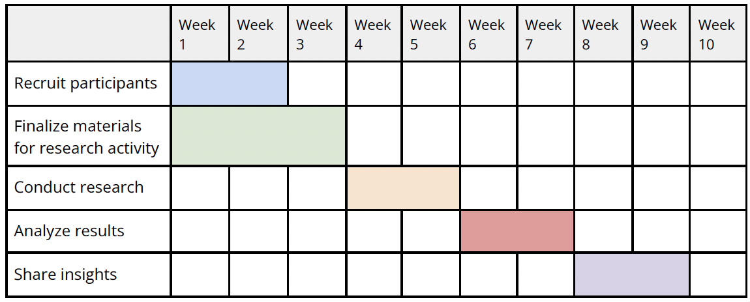

**Task list**

* Complete research plan
* Draft one-pager
* Draft recruitment email
* Set up scheduling tool and automated reminders
* Recruit participants
* Prep guides and scripts for interviews/usability tests
* Create notes for each session
* Debrief with the team after each session
* Upload session recordings and notes
* Send thank you notes to participants
* Analyze transcripts
* Draft insights
* Create report slide deck
* Create one-pager
* Share research results back with participants

# Research Brief One-Pager

Use this template to introduce your research to an audience, such as leadership or research participants. We recommend including background on how this project arose, its aims, plus anticipated deliverables and timelines for results. Be sure you have also done due diligence to look at previous research so that you are not replicating anything.

## Purpose of research

*Share the purpose of your research here. Why are you conducting it? What aims will it facilitate? You can also share a bit about the background of how this research project arose. Give stakeholders the context they need to decide if they want to participate.*

## Research logistics

This research study will include **X** in-depth interviews, 30 minutes to one hour in length, conducted by a trained researcher between the weeks of **X** and **Y**. Questions will touch on **ABC**. Scheduling will be coordinated through Calendly. All research findings will be reported anonymously.

## **Research goals** [optional]

Our research goals are:

1. [*Insert goal here*]

## Deliverables

After the research, we’d like to share back with you what we found. This could take the form of a research report, one-pager, or other deliverables.

Put what you plan to share back with participants. Make sure you’re sharing something.

# Communications Templates

## 

## Template for a usability test

**To** Potential participants

**Subject** Help us test **[thing to be tested]**!

Dear [Name],

We are in the midst of testing **X** and we would love to invite you to help. The purpose of **X** is to **XYZ**. By helping us test it, you'll be helping to support **[XYZ purpose]**.

You can read more about the study **here[insert link to one-pager]**. Sessions will be recorded (but kept anonymous) with your consent. If you have interest and availability to help, please **click here[insert Calendly link]** to schedule a testing time.

Thank you so much for your time and consideration. We hope to see you at a testing session soon!

Wishing you well,

**[Your name]**

On behalf of **[insert team name]**

## Template for an interview

**To** Potential participants

**Subject** Help us learn about **X**

Dear **[Name]**,

We are in the midst of a study to learn about **X**. We heard from **[insert recommender name]** that you would be a great person to talk to about that. We would love to conduct a one-hour interview with you.

The purpose of this study is to **XYZ**. By helping us learn about **X**, you'll be helping to support **[XYZ purpose]**. You can read more about the study **here[insert 1 pager link]**. Interviews will be recorded (but kept anonymous) with your consent. If you have interest and availability to help, **please click here[insert Calendly link]** to select an interview time.

By [*insert date*], we expect to be able to share with you the outcomes of this research. Some example deliverables you may expect are:

[**1 report slide deck]**

**[1 summary one pager]**

**[Insights]**

We care about your informed consent. To learn more about how we will protect your privacy and your options for participating, please read through the informed consent form PDF attached.

Thank you so much for your time. We hope to connect with you soon!

Wishing you well,

**[Your name]**

On behalf of **[Insert team name]**

**Template for a follow-up email**

**To** Participant   
  
**Subject** Thank you for your time and feedback!

Dear [**first name**],

Thank you so much for participating in our interview on [date]! We know you are extremely busy, so we really appreciate you taking the time to share your thoughts, expertise, and perspective. Hearing your insights about [***insert X topic here***] was especially helpful.

Over the next **X** weeks, we will be analyzing the data we received from you and other participants. We will make sure to anonymize your data as much as possible. In order to protect your privacy, we will not quote you by name. This data will be kept in our research archive and will be visible to human-centered design practitioners in the OIT space.

Then, around [***insert timeframe***], we should have results ready to share back with you. If you do not wish to be kept informed about the outcomes of this research, please just let us know.

If you have any questions or concerns about your participation or how we’ll use your data, feel free to reply to this email, or contact [insert contact email]. In the meantime, we hope you’re having a wonderful day!

With gratitude,

[**Insert team member names**]

## Template for a post-study follow-up email

**To** Participant   
  
**Subject** Findings from your usability test

Dear [**first name**],

Thank you again for participating in our interview on [date]! As promised, we have the results from the [***insert X topic here***] study you participated in on [***insert date***].

[***insert summary of findings or graphics from report***]

If you have any questions or concerns about your participation or these results, feel free to reply to this email, or contact [insert contact email]. In the meantime, we hope you’re having a wonderful day!

With gratitude,

[**Insert team member names**]

# Informed Consent Options

## Informed consent one-pager

*This is optional, it’s available for use as needed. You can use this or the script below.*

**What This Study is About**

The [**insert team name**] is conducting a series of interviews to learn about **X**. Your participation will help us understand **Y** and create **Z** for users in this space.

**Your Involvement in the Study**

In a video call, we’ll ask you questions about **X**. With your permission, we’ll record the audio and video of our conversation, and we’ll take notes to document your comments. Your participation is voluntary. You may take a break, decline to answer a question or leave the interview at any time, for any reason.

**How We Will Use Interview Data**

The primary researcher and their teammates will view recordings or notes in the future. If they so choose, they may also upload it with a transcript to our shared research archive, where HCD practitioners and others in CMS can view the recording and transcript. But we will be sure to anonymize your data by referring to you with a unique identifier. Reports may be published with anonymous comments.

**Storage of Session Data**

We will store and process your personal information and session data in the U.S. by hosting it on [Google Drive, Box, shared drive, etc.] indefinitely until we deem the content no longer necessary. You can, however, request that your information be deleted after the study ends.

**Your Consent**

By participating in this interview, I understand the following: The session will be recorded (through video, audio, or observer notes); researchers may view the interview recording and documentation; researchers may quote you anonymously in reports and presentations. The default is for interviews to be video recorded and transcribed. If you would prefer that your interview be done audio-only or observer notes-only, please let the research team know.

## Informed consent script

*All research should have the informed consent of participants. However, historically across OIT HCD teams, there hasn’t been a standard way of asking for consent. Either this verbal script or the prior form can be used uniformly across research projects to ensure participants have adequate information to willingly take part in the research.*

**Intro**

Thank you so much for taking the time to participate in this research activity. Before we get started, we want to share about this research and how your data will be used. That way you can understand what it means to take part in this study.

**Purpose of Research**

The purpose of this research is to… [***insert purpose***]. Your participation will help to [***insert X benefit of research***].

**How Your Data Will Be Used & Stored**

You can choose to be interviewed but not recorded. You can also choose to have your camera off. If you are fine with us recording the interview, we’ll upload it with a transcript to our research archive. People with access to the archive can view the recording (usually practitioners of human-centered design in the OIT space). We’ll anonymize your data by using a unique identifier instead of your name. Some identifying information may remain though (for example, your face in the recording). We may also upload notes.

**What You Can Do**

At any time, you can choose to stop the interview or decline to answer a question. You can always contact [***insert contact email here***] with any concerns or questions.